**CHAPTER 1   
INTRODUCTION**

1. Introduction

Cloud Base is built to simplify movie management for users, allowing them to upload, view, and manage movies in a secure and organized way. The core functionalities of the website include User Signup & Login, Account Management, Movie upload.

User Signup & Login Allow users to create accounts, log in using JWT, and securely authenticate their sessions. In account Management users can edit their profiles and delete their accounts when needed. In movie upload Users can upload movies with metadata such as title, details, release date, etc., along with movie files and posters. This report explains the system design, implementation process, libraries used, challenges faced, and the future scope of the project.

* 1. **Problem Summary & Introduction**

The problem is there are so many websites that provide movies which can be downloaded from the data base. Our website will provide extra functionality of uploading movies to any user who have an account in the Cloud Base website. This will help to find out movie easily and maximum number of users can upload more movies. This help to get maximum chases to find the movie which the user wants to download. This website doesn’t need any specific team to find movies and upload on the database. This website is initially for movie management but the vision is to make it bigger so that user can find everything on this website browsing. This website will able to do the same things for games, images, iso files, presentations files, word files, tv shows, web series, and any kind of document that user wants to download and brows. We will also provide and person storage so the user can store their personal documents and file in it.

* 1. **Aim and Objectives of Work**

**Aim**: The aim of this project is to develop a cloud-based platform for secure storage and management of digital files, starting with movies and expanding to other types like games, music, and software. It focuses on providing seamless access, scalability, and an enhanced user experience.

**Objective**: The objective is to create a user-friendly system that ensures data security, supports diverse file types, and offers real-time access across devices. The platform will integrate advanced cloud technologies to optimize performance and scalability.

* 1. **Problem Specification**

This project addresses the need for secure file storage, user account management, and easy access to various file types including movies, games, TV shows, presentations, and PDFs, all on a single platform. This eliminates the need for users to visit multiple websites to find different types of files. By consolidating these features, our platform provides a convenient and efficient solution for users, saving time and effort while ensuring their data is secure and easily accessible.

* 1. **Plan of Work**

**Table 1.1: Gantt Chart**

|  |  |  |  |
| --- | --- | --- | --- |
| Sr no | Task Name | Month | Week |
| 1 | Research about various platforms |  |  |
| 2 | Team formation |  |  |
| 3 | Select the Domain and Research Project |  |  |
| 4 | Initial Project Presentation |  |  |
| 5 | Research about how available digital data platforms |  |  |
| 6 | Implementation of user model |  |  |
| 7 | Implementation of tracking details like login and signup |  |  |
| 8 | Implementation of Movie upload system and interfaces |  |  |
| 9 | Implementation of user interfaces to download movie by routers |  |  |
| 10 | Initilization of Admin router and management |  |  |
| 11 | Implementation of interface for admin |  |  |
| 12 | Implementation of interface for movie management & Download (Admin side) |  |  |
| 13 | Prepare Project Report |  |  |

* 1. **Tools required**
     1. **Hardware Requirement**
        1. Monitor: Any Monitor
        2. Minimum RAM: 1 GB
        3. Hard Disk: 40GB
        4. Processor Size: 32bit or above
        5. Operating System: Windows XP or above
     2. **Software Requirement**
        1. Node.js
        2. MongoDB
        3. Express
        4. Multer
        5. jsonwebtoken
        6. cookie-parser (v1.x or higher)

**CHAPTER 2:**

**REQUIREMENT**

**ANALYSIS & DESIGN**

* 1. **Requirement Analysis Model**
     1. 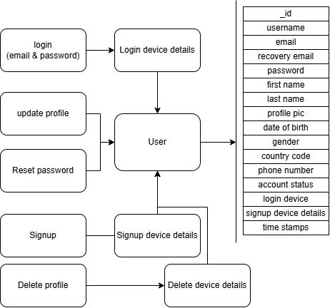**ER -Diagram**

**Figure 2.1: Full user ER Diagram**

* + 1. **Data flow Diagram**

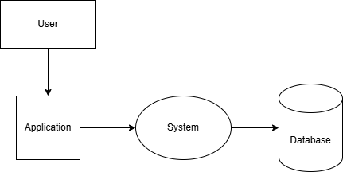

**Figure 2.2: Application work flow**

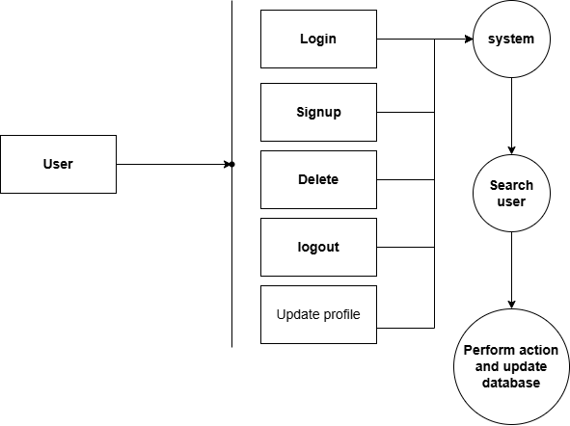

**Figure 2.3: User operations**

* 1. 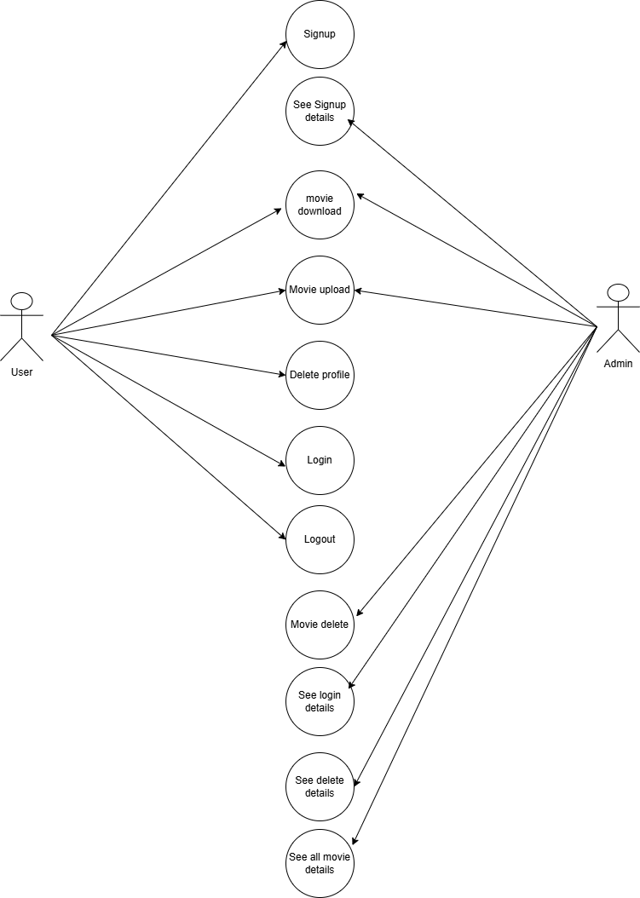**Use Case Diagram**

**Figure 2.4: All operations of database**

**CHAPTER 3:**

**IMPLEMENTATION**

* 1. **System Design**
     1. **Architecture**

The Cloud Base system follows a client-server architecture.

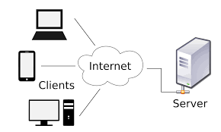The client side is built using HTML, CSS, and EJS for rendering dynamic pages (like the homepage, movie upload forms, etc.). The front-end interacts with the server via HTTP requests. The back-end is developed using Node.js with the Express framework, handling routing and managing HTTP requests. For database MongoDB stores data related to users and movies, including metadata and file paths. It has models like movies and user which uses mongoose schemas like user scheme, login request details, delete request details, and movie schema. This schema contains metadata details about models. The system uses JWT (JSON Web Token) for securely managing user authentication. JWT tokens are generated during login and used for verifying the user in subsequent requests

**Figure 3.1: Client server architecture**

* + 1. **Database Design**

in MongoDB, a collection is a group of documents, similar to a table in relational databases. Each document has a unique _id field and can have different structures. Collections can be indexed for faster queries. MongoDB supports operations like inserting, querying, updating, and deleting documents and more. This database contains 4 models which are given below.

1. Deleted device details Collection
2. Login device detail Collection.
3. Movies Collection
4. User Collection
5. Admin Collection

This all collections have their own schemas and databases in mongodb.

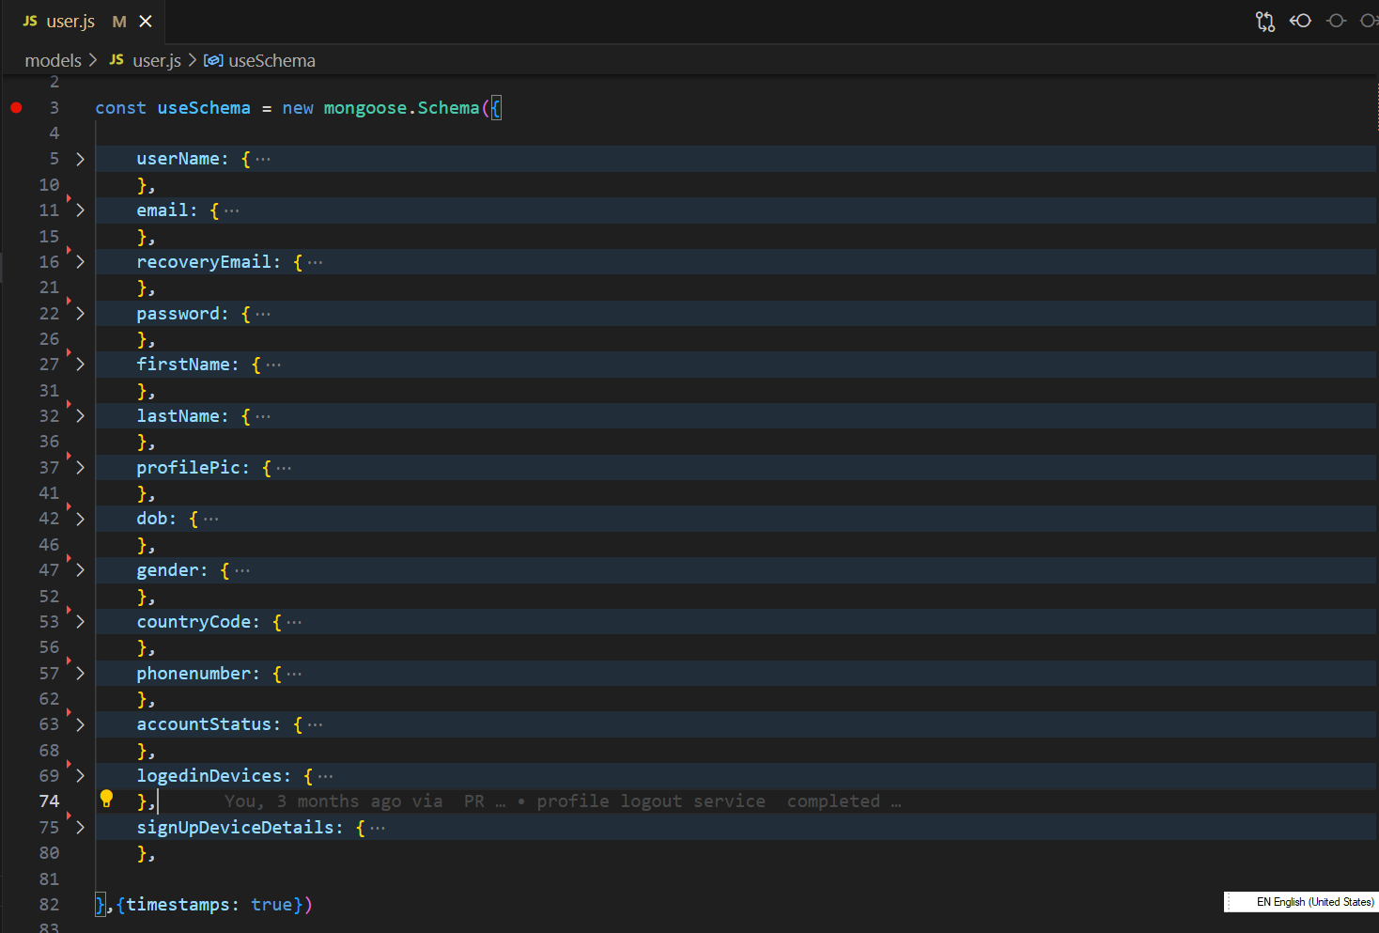In user Collection email, password, username, first name, last name, phone number, status (active/deleted), createdAt, profile picture path, database path, date of birth, country code, phone number, login device array (initially empty), signup device details & updatedAt are the details thar stored in database.Username, email, _if & phone number will be always unique. It stores user detail at mongodb with this all fields and use it by mongodb queries to operations login, authentication, verification etc.

**Figure 3.2: User schema**

In Movie Collection title, description, title name, ucbid, release date, duration, cast, poster path, movie file path, available audio tracks, subtitle tracks, director, size, original file data, released in country, resolutions, uploadedBy, total visits, total ratings, total downloads, createdAt, updatedAt, total online streams etc. stores movie metadata along with the file paths for movie posters and movie files uploaded by users.

In Login device detail Collection _id, hostname, os username, is loginsuccessfull, os machine type, os name, os, os version, home directory, free system memory, total system memory, device Ip, Wi-Fi mac address, CPU architecture, CPU model, CPU speed, CPU cores, temporary directory location, Browser, Browser version, createdAt & updatedAt are the model keys defined in mongodb model. It stores all this information in the database as object. This basically tracks browser requests.

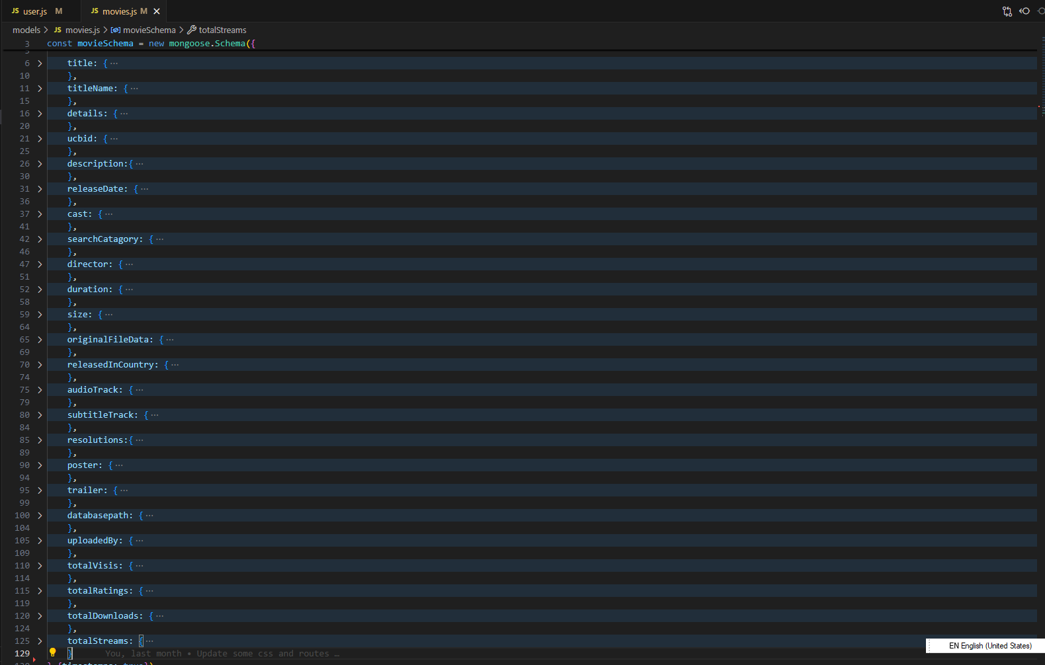Deleted device details Collection have fields like _id, hostname, os username, is loginsuccessfull, os machine type, os name, os, os version, home directory, free system memory, total system memory, device Ip, Wi-Fi mac address, CPU architecture, CPU model, CPU speed, CPU cores, temporary directory location, Browser, Browser version, createdAt & updatedAt. It stores all this information in the database as object. This basically tracks browser requests.

**Figure 3.3: Movie Schema**

* + 1. 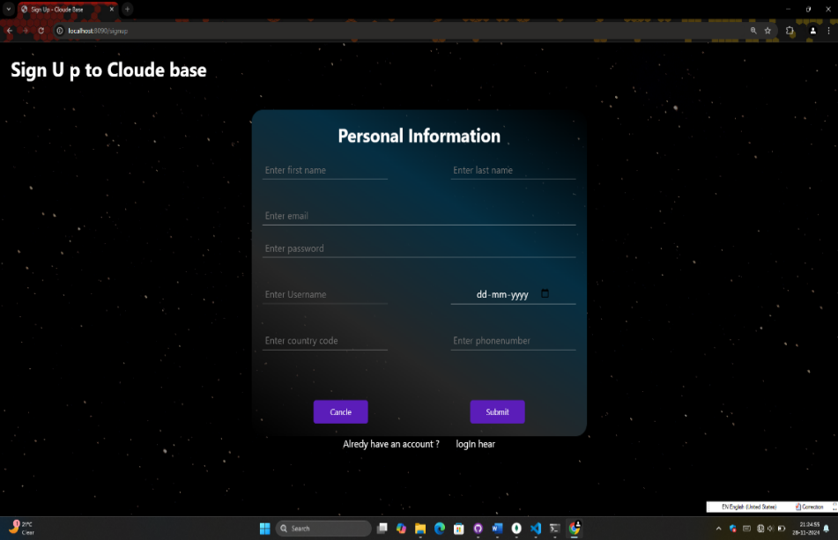**Flowcharts**

In User Signup Flow user enters details (email, password, etc.) on the signup page (Signup page contain all fields according to the user schema). After this, server will check that if user is already available or not. If user already available then user should login else user can create account with the email. Server validates inputs (checks email format, password strength). Now server will make a database document using the user schema, model and input data and redirect to the login page.

**Figure 3.4: Signup page**

In User Login Flow user will enter email and password to the login page and send those details to server by poste request. These details will be received by server and server will check the email and password with the database document. If the email found in the database, then process will be continued otherwise server will tell user to create an account. If the email found in database, then it will check if the password is correct or not. If the password is not correct then server tells user to enter correct password. If the password is right then a JWT token will be generated by the JWT library and it will send to the user with next response as a cookie and render the index.ejs page.

In Movie Upload Flow user will fill the form which contains all field according to movie schema and send it to server by using POST request. Server will check if movie is uploaded or not. If it was uploaded then server tells the user to select different username. If it was not uploaded then server will wrap this all movie-details to an object and send it as cookie with rendering files upload page. Movie poster and movie file will be uploaded by this page and sent to the server by post request where it will handle by multer (File uploading library). With this request server will take the movie d ata from cookies and they will be stored in MongoDB including file paths, and the server responds with a success message.

* 1. **Implementation Workflow**
     1. **User Signup Process**

The user enters details like email, password, username, first name, last name, date of birth, country code, phone number and submits the form. A ` POST` request is sent to the server’s `/signup` route. The server receives the form data. It will check if the email is already in use or not. If the email is already in use, then server tells user to add different email. After this, server will check that the username is already taken or not. If user name is already taken then user should enter unique username. Third condition is unique phone number. If this all conditions are satisfied then server will ensure that all required fields are provided. Server will collect device details from the browser request like os name, os version, browser details, CPU details, host name, machine name, os name, home directory, total memory, free memory, temporary directory, and device Ip. This device details will be wrapped in object and added in the user object with name “SignupDeviceDetails”.

**Figure 3.5: Signup page**

The server creates a new user document in the MongoDB User by using mongodb queries and operations. This process is synchronising process so the callback function of the route is async function and database operation will wait for finish earlier processes. The user object will be passed in mongodb create operation and user will be redirected to the login page after completion of the process.

* + 1. **User Login Process (JWT Authentication)**

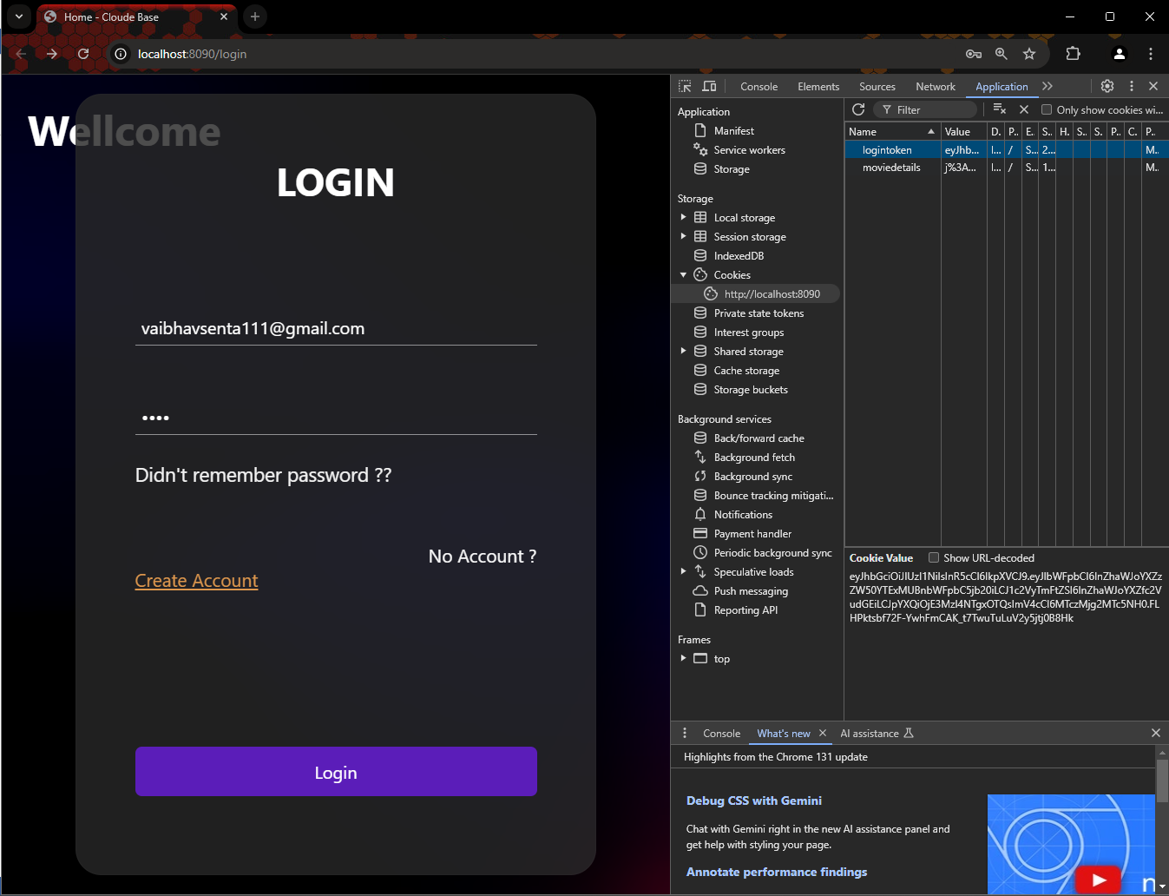The user enters their email and password and submits the form. A `POST` request is sent to the server’s `/login` route. The server checks if the email exists in the database. If the email is not found in the database, then server tells the user to create an account at CLOUD BASE. If email found in the database, then server will match the password with database. If email and password both will match with database then the process will be forwarded. If the credentials are correct, the server generates a JWT token using jsonwebtoken. The token contains the user’s email and username. This token will sign by using passkey so only server can modify it.

**Figure 3.6: JWT Authentication by Cookie**

The expiry of JWT token will set to eh 1h. After 1h JWT token will expire and user needs to login again at the website. The token is sent as a cookie named as “logintoken” to the client for use in subsequent requests. By default, browser catch cookies and sent them with every request. If the login is successful, the user is redirected to the home page or the dashboard. The JWT token is stored in the user's cookies for session management. With every request, this login token will send to the server and every time server will verify the cookie data and expiration. After verification server find user with the email received from login token and add that at “req. tokenuser”.

If the cookie will not receive by the server or expired then as a response user will be logged out at next response and user need to login again to the website.

* + 1. **User Logout Process (Manually)**

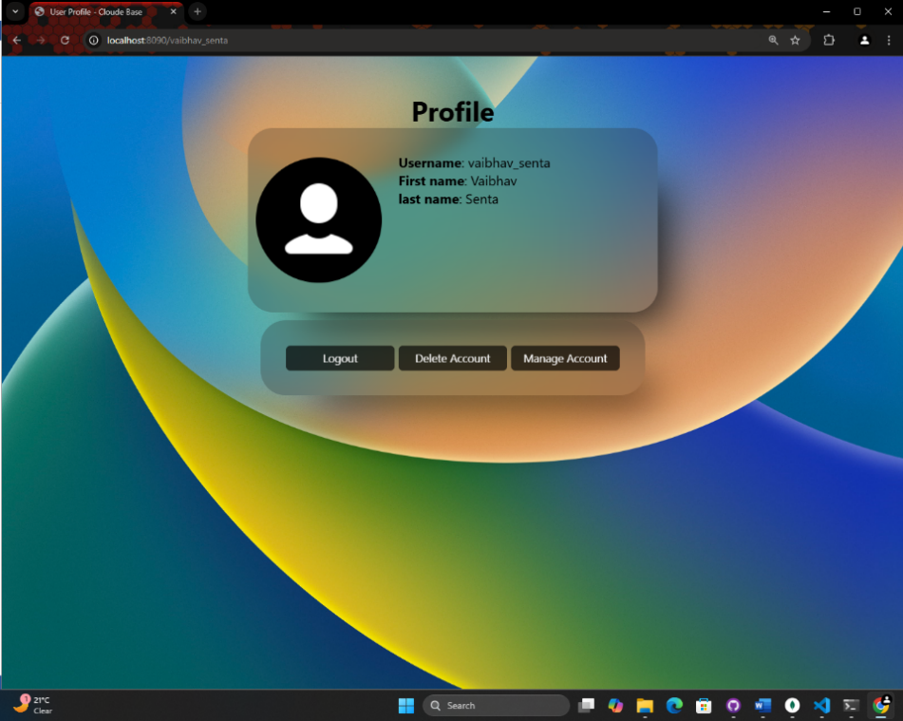First user should be logged in to the website. Visit “/: profile” and send logout request. User will visit to “:/profile” route which is a dynamic route for usernames. This route is basically profile page which has 3 buttons logout, delete Account & manage Account. User will click on the logout button and this button will send request to server. Server will receive a GET request. The request sent by logout button is GET request to “:/profile/logout”. By receiving this request, server will verify the login token and if the user is logged in the process will be continued. If user logged in then server sent clear cookie response to the user that clear the cookies from the user browser. And the user will be logged out.

**Figure 3.7: Logout (Manually)**

* + 1. **User Delete Process**

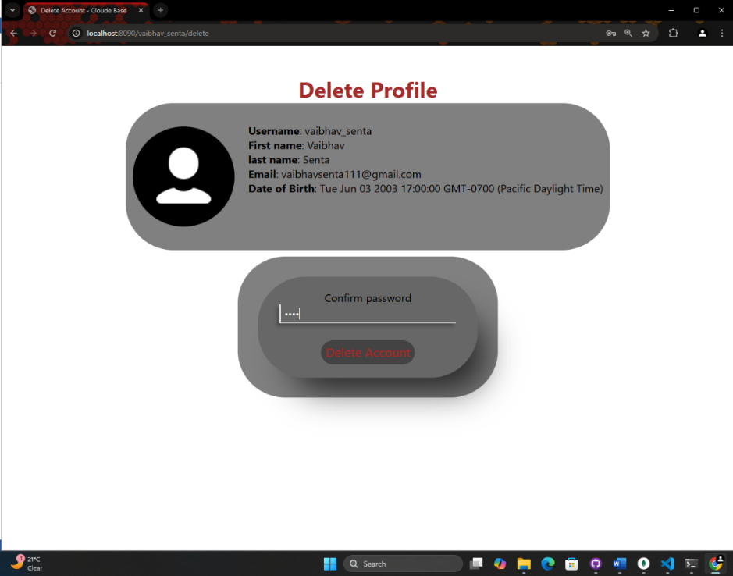Visit at profile page which is located at “/: profile”. Click on the delete button which sent a GET request to the server. User should be logged in, check if logged out. Server will check that user is logged in or not. If the user is not logged in than process will be stope. If the user is logged in then server will send a form that contain some details about your account. Fille the form and send request. Verify the details of your account and fill the form with account password. This form will send a POST request to the server at button click. Check if user already deleted and delete user. Now the server will check that the user is already deleted or not. If user is mark as delete then server respond that user is already deleted from. If user ins not deleted then server will verify the password with database and password match then change the user’s account-state from “active” to “deleted”

**Figure 3.8: Profile delete page**

* + 1. **User or Profile Update Process**

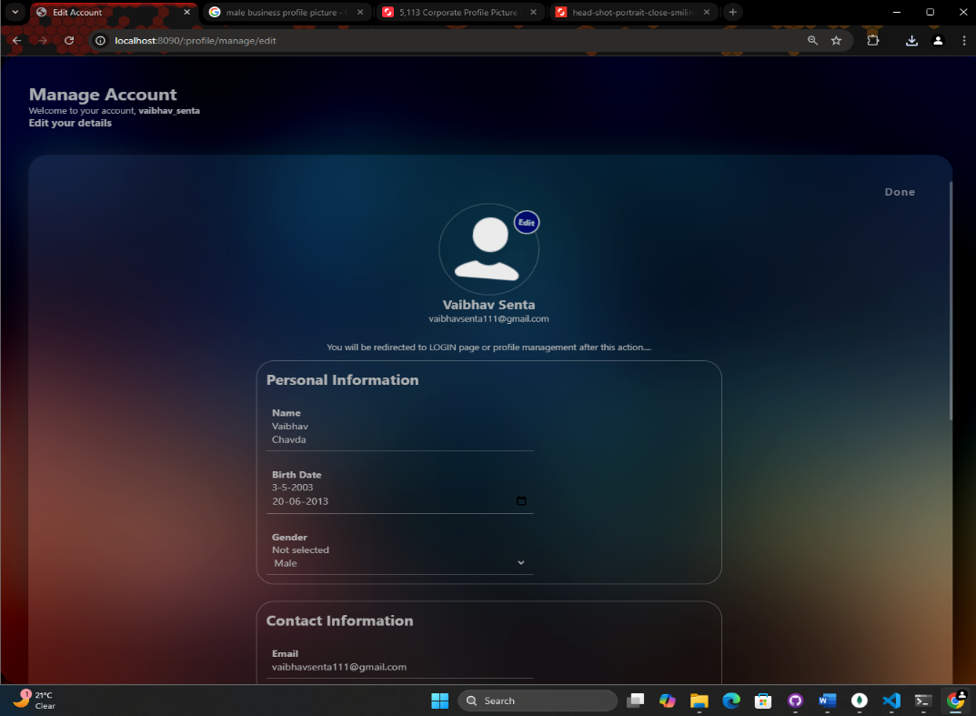Visit to profile manage page by clicking on the manage account button which is GET request. When you visit the manage page, server will get login token from “req. logintoken” and find the user by database process and collect the details like email, recovery email, phone number, date of birth, profile picture, first name, last name etc. These details will be passed and sent with the manage page . Visit to “/: profile/manage/edit”. Now, there is a button which sends GET request to the server. By clicking this button, server will send a form which contains input fields and select options to update the details. Select profile image if want to update and fille the detail that user wants to update. On submit, this form sends POST request to the server with form data. This request will be received by the server. Server scans the form and remove empty fields from req.body object by different types of processes. Now, server will wrap all this details to another object by adding additional information. After this, the server executes find and update process and pass the new object in the process. Now, profile data will be updated and server will send response to the user.

**Figure 3.9: Profile update page**

* + 1. **Movie Upload Process**

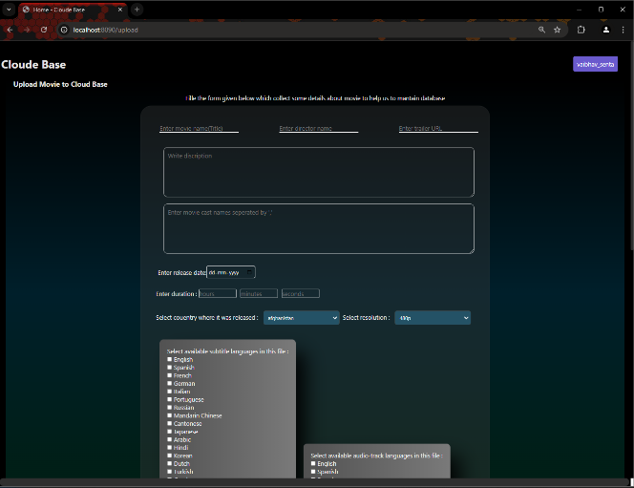User will fill the form which contains all field according to movie schema and send it to server by using POST request. Server will check if movie is uploaded or not. If it was uploaded then server tells the user to select different username. If it was not uploaded then server will wrap this all movie-details to an object and send it as cookie with rendering files upload page. The user selects a movie file and its poster image. Metadata will receive with the response. The movie data and files are submitted to the server as a multipart/form-data request, handled by Multer. The POST request will send to the server. Movie file and movie poster will receive at “req.files”. Server will receive movie details from cookie named “moviedetails" and store it to 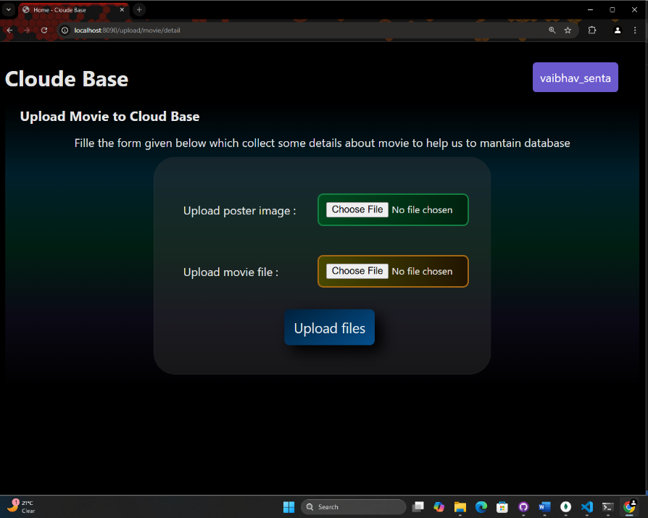object. Now, server will collect some information from file like file-size, poster-path, database-path and other original data of the files. This information will be added to the moviedetails object. ow, the files will be uploaded and details will be saved in database by creating new database document. Multer handles the file upload. The movie file is stored in the `uploads/` directory on the server. The movie poster image is also uploaded and stored in the `uploads/` folder. The movie metadata, including the file paths (for both the movie file and poster), is stored in the Movie collection in MongoDB. Once the movie is uploaded and stored, the server responds with a success message (e.g., "Movie Uploaded Successfully").

**Figure 3.10: Movie detail form**

**Figure 3.11: Movie file upload form**

* 1. **Challenges Faced**

Uploading large movie files posed a challenge. Multer was used to handle multipart uploads, and file size limits were enforced to prevent excessive storage use.

Managing JWT tokens securely is crucial for preventing unauthorized access. Tokens expire after a certain period, requiring users to log in again. We implemented a secure token storage mechanism via cookies and used HTTPS to protect sensitive data.

Ensuring that user input (e.g., email, password) is valid required thorough input validation to prevent invalid data from being entered into the system.

* 1. **System Requirements**

Software Requirements

* Node.js
* MongoDB
* Express
* Multer
* jsonwebtoken
* cookie-parser (v1.x or higher)

Hardware Requirements

* CPU: Dual-Core Processor (minimum)
* RAM: 4GB or higher
* Storage: 50GB or more (for large movie file storage)
  1. **NPM libraries used in**

This node.js project uses Express with Node.js server-side language. There are some more things that are helpful to build this and make it easier. Npm (Node Package Manager) is a package manager for JavaScript, primarily used for managing libraries and dependencies in Node.js projects. It allows developers to install, update, and manage third-party packages or modules, which can be reused in their applications. npm also helps manage scripts and automation tasks, making it easier to set up, configure, and run projects. It comes bundled with Node.js and provides access to a vast registry of open-source packages through the command line. The npm packages used in this project is given below…

* cookie-parser
* ejs
* express
* jsonwebtoken
* mongoose
* multer
* os
* path
* short-unique-id
* useragent

**cookie-parser**

Parse Cookie header and populate req.cookies with an object keyed by the cookie names. Optionally you may enable signed cookie support by passing a secret string, which assigns req.secret so it may be used by other middleware. You can pass a secret key to the middleware to sign cookies, providing additional security (e.g., req.signedCookies for signed cookies). This middleware is commonly used in applications that need to manage user sessions or store small pieces of data in cookies.

Installation: npm install cookie-parser

API: var cookieParser = require('cookie-parser')

Use: app.use(cookieParser());

Example:

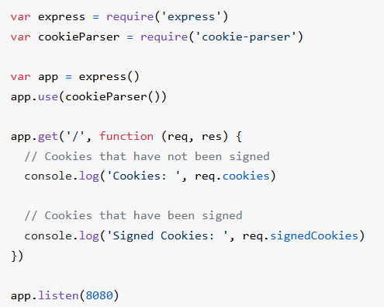

**ejs**

EJS (Embedded JavaScript) is a templating engine for Node.js and Express that allows you to embed JavaScript code into HTML templates. It helps generate dynamic HTML content by rendering data on the server-side before sending it to the client. EJS enables the creation of reusable HTML components with logic (loops, conditionals) embedded directly into the template. Allows you to embed JavaScript directly within HTML using <%= %> for output and <% %> for logic (e.g., loops, conditionals). You can pass data from your server-side code (like Express routes) to the template for rendering dynamic content.

Installation: npm install ejs

Example:

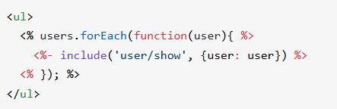

**express**

The Express philosophy is to provide small, robust tooling for HTTP servers, making it a great solution for single page applications, websites, hybrids, or public HTTP APIs.Express does not force you to use any specific ORM or template engine. With support for over 14 template engines via [Consolidate.js](https://github.com/tj/consolidate.js), you can quickly craft your perfect framework.

Installation: npm install express

Example:

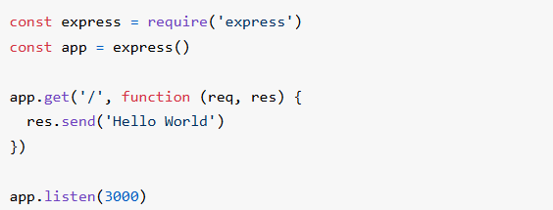

**jsonwebtoken**

JSON Web Tokens (JWT) are a compact, URL-safe way to represent claims (data) between two parties, commonly used for authentication and authorization in web applications. A JWT consists of three parts: a header (containing metadata), a payload (carrying the claims or data), and a signature (used to verify the integrity of the token). Once a user logs in, the server generates a JWT and sends it to the client, which stores it and sends it in subsequent requests. The server verifies the token and grants access to protected resources if valid. JWTs are stateless and self-contained, meaning they don't require server-side session storage, making them scalable and ideal for microservices. They can also carry user roles or permissions for authorization. Popular libraries like jsonwebtoken make it easy to create and verify JWTs in Node.js. However, it's important to secure the secret key and use HTTPS to protect tokens during transmission.

Installation: npm install jsonwebtoken

Example:

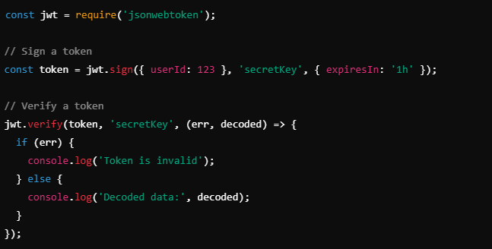

**mongoose**

Mongoose is an Object Data Modeling (ODM) library for MongoDB and Node.js that provides a higher-level abstraction for interacting with MongoDB databases. It allows developers to define schemas for their data, providing structure and validation to the otherwise schema-less MongoDB collections. With Mongoose, you can define models based on these schemas, which represent documents in a MongoDB collection. It simplifies tasks such as querying, data validation, and data manipulation by providing an easy-to-use API. Mongoose also supports middleware, enabling developers to define hooks for actions like document validation or saving. It integrates seamlessly with MongoDB and is widely used in Node.js applications to manage database interactions in a more organized and efficient manner.

Installation: npm install mongoose

Example:

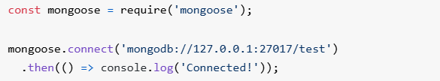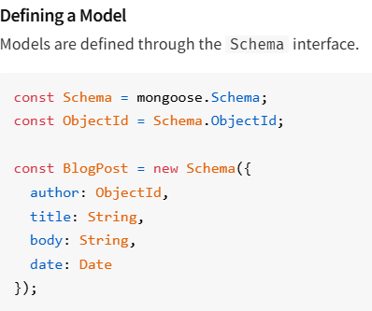

**multer**

**Multer** is a middleware for handling **multipart/form-data,** which is commonly used for uploading files in **Node.js** applications. It is typically used with **Express** to simplify the process of receiving files from HTTP requests. Multer processes incoming form data, storing the uploaded files either in memory or on disk, depending on the configuration. It allows developers to define custom storage locations and manage file naming conventions. Additionally, Multer provides the ability to validate files by setting constraints such as file type, size limits, and more. It is easy to integrate into an existing application and offers features like support for multiple file uploads and the ability to handle large file transfers efficiently. Multer is widely used in web applications that require file upload functionality, such as for image galleries, document management systems, and media platforms.

Installation: npm install multer

Example:

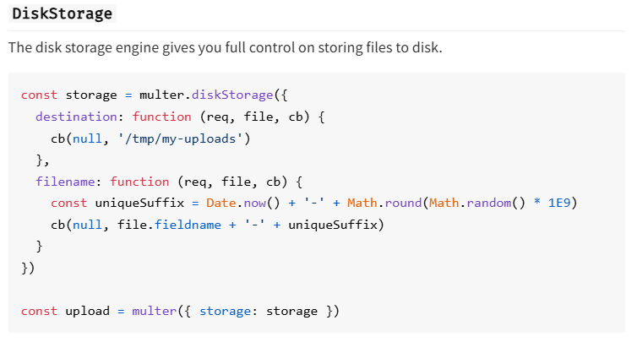

**Os**

The os module in Node.js is a built-in module, meaning it comes with Node.js by default and does not require installation via npm. It provides a set of operating system-related utility methods for retrieving information about the computer system, such as CPU details, memory usage, network interfaces, and the operating system platform.

Built in module

**Path**

The path module in Node.js is a built-in module used to work with and manipulate file and directory paths. It provides utilities to handle different aspects of file paths in a platform-independent way, such as joining, resolving, or normalizing paths, which is especially useful for cross-platform applications (Windows, Linux, macOS) where file path formats differ.

Installation: npm install path

Const path = require(‘path’)

**short-unique-id**

short-unique-id is a lightweight npm package designed for generating short, unique, and random strings. It's commonly used in applications that require concise, URL-safe identifiers, such as generating user session tokens, random keys, or short links. The package provides an easy way to create IDs with customizable lengths, which can include alphanumeric characters and be used in various scenarios, from database keys to temporary tokens.

Installation: npm install short-unique-id

Example:

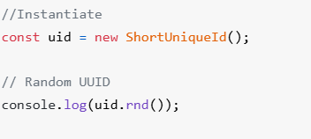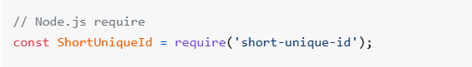

**useragent**

useragent is a npm package used to parse and analyze User-Agent strings, providing detailed information about the client's environment. User-Agent strings are sent by browsers or other HTTP clients to identify themselves, and they contain data about the operating system, browser type, version, device, and more. The useragent package helps developers extract and interpret this information in a structured way, allowing for better handling of user requests based on their browser or device.

Installation: npm install useragent

Example:



**CHAPTER 4:**

**PROJECT SUMMARY**

**AND FUTURE WORK**

* 1. **Future Enhancement**

1. AI-Based Movie Recommendations:

Collaborative Filtering, this technique can recommend movies to users based on the preferences of other similar users. For example, if two users have similar viewing habits, the system can suggest movies one user liked to the other.

In Content-Based Filtering using metadata like genres, actors, or movie ratings, the system can recommend movies that are similar to ones the user has already watched.

In Machine Learning Models, You could train a recommendation model using TensorFlow or Scikit-learn, leveraging movie ratings, reviews, and user preferences to improve the accuracy of the suggestions over time.

1. Cloud Storage Integration:

AWS S3: Transitioning to Amazon S3 for storing movie files could help improve scalability. S3 offers high durability, scalability, and security for large files. CDN for Faster Access, Using a Content Delivery Network (CDN) like CloudFront in combination with S3 will enable faster access to media files, especially for users located in different regions.

1. Advanced Search Filters:

Genre Filters: Users could search for movies by genre, and the system could dynamically load the relevant movies based on genre. Release Date Filters: Allow users to filter movies by release year or decade. This could be a useful feature for discovering older or new releases.

Rating and Popularity: Sorting by user ratings or movie popularity could help users find the best-rated or trending films.

Tagging System: Implement a tagging system to allow users to find movies based on keywords or themes (e.g., “action”, “romantic”, “award-winning”).

1. Enhanced User Experience (UX):

First in this is Personalized Dashboards. Each user could have a personalized dashboard that shows their recently watched, recommended movies, and favorite genres. Second one is Voice Control Integrate voice assistants (like Google Assistant or Alexa) to allow users to control movie playback, search for movies, or add movies to their collection via voice commands. And the last is Mobile App: Create a mobile app for Cloud Base so users can manage their movies on the go. This app could be built using React Native to keep it cross-platform (for both Android and iOS).

1. Social Features:

User Reviews and Ratings: Users can leave reviews and rate movies they’ve watched. This could help others find great movies and improve the recommendation system. one of the social features is Movie Sharing that allow users to share their movie lists with friends, fostering a more social movie discovery experience. other social feature is watching Parties. Implement a feature where users can watch movies simultaneously with friends and chat about it in real-time.

1. Enhanced Security and Privacy:

Adding 2FA during login to increase account security. End-to-End Encryption where we Encrypt sensitive data such as user details, preferences, and payment information to ensure privacy and security. Audit Logs: Maintain logs of all user activity (with proper permissions) for security monitoring and issue tracing.

1. Multi-File Type Support:

Integrate support for game downloads, with added metadata for each game (e.g., system requirements, genre, etc.). Expand movie management to include general video uploads, categorized by type (e.g., tutorials, vlogs, etc.). Add a music streaming feature with album artwork, playlist creation, and recommendations based on listening history. Support for application installations, updates, and licensing management. Allow users to upload and manage ISO files for software and operating system installations. Provide secure cloud storage for personal files like documents, photos, and more, with encryption for privacy. This website will hold most of all file types.

1. Content Sharing and Collaboration:

Allow users to share files or folders with others through secure links. implement shared spaces where users can collaborate on documents, projects, or even gaming communities.

1. Content Streaming & Playback:

Add features for live streaming (e.g., for video or music), so users can upload content and stream it in real-time.

* 1. **Advantages**

1. Scalability:

The system is designed for future expansion, with the ability to add new file types (games, music, applications) and services (live streaming, cloud gaming). Seamless addition of new features without disrupting the core functionality.

2. User-Centric:

Personalized experiences based on user behavior (file types, preferences, etc.), improving engagement. Easy-to-use interface that allows users to manage a variety of media (movies, music, games) in one platform.

3. Multi-Platform Support:

Accessible via desktop and mobile apps, making it flexible for users who want to access their content anywhere. Future compatibility with smart devices (IoT), enhancing usability

4. Convenience:

Centralized platform to manage multiple types of media (movies, music, games, software, etc.), removing the need for different apps or services.

5. Streaming:

User can stream movies and videos and image on website.

* 1. **Conclusion**

The Cloud Base project provides an innovative and secure platform for managing file storage, addressing the challenges of data accessibility, security, and scalability. By utilizing modern technologies such as Node.js, Express, and MongoDB, the platform ensures efficient handling of both personal and public file storage needs. The integration of role-based user access enables administrators to maintain complete control over database operations, while regular users benefit from features like secure uploads, downloads, and account recovery. With a strong focus on data security, the project incorporates encryption for sensitive user information, ensuring user privacy and data integrity. The detailed file metadata management system for movies and other files further enhances the platform’s functionality, making it suitable for diverse use cases. Its user-friendly interface and scalable architecture provide a seamless experience for users across devices, making file storage and management hassle-free. The Cloud Base project not only solves existing storage challenges but also establishes a robust framework for future development. Potential enhancements, such as advanced analytics, AI-based file recommendations, and additional storage optimization features, could expand its applicability in various domains. In conclusion, Cloud Base demonstrates how modern web development tools can effectively solve real-world problems, offering a reliable, scalable, and secure file storage platform that can cater to diverse user needs